**PYTHON PROJECT**

**MAD LIBS GENERATOR**

**BY: NIKHIL SHARMA -1118**

**RISHBAH SINGLA-1128**

**B.tech CSE 4A**

**CODE SNIPPET:**

**import random**

**print('\t---------------------------')**

**print('\t\tMad Libs Generator')**

**print('\t---------------------------')**

**print('\t\tBY:NIKHIL SHARMA-1118\n\t\tRISHABH SINGLA-1128')**

**print('\n\t\t\tmenu\n1.randomly predefined lists \t2.input from user\n')**

**def funcpre():**

**random_name=['Sam','Jhon','Karan','Shubham','Shreya','Nidhi','Pari']**

**your_name = ['Nikhil','Rishabh']**

**place = ['park','mall','cafe','club']**

**adjective =['amazing','beautiful','wonderful','marvellous']**

**adjs = ['Chatty','brave',"Crazy", "Nice", "Lovely", "Gross"]**

**verbs = ['beat','drawn','drove',"met", "proposed to", "robbed", "pushed"]**

**prepositions = ['beneath','under',"above the", "near the", "around the", "behind", "beside"]**

**print(random.choice(adjs) + " " + random.choice(random_name) + " " + (random.choice(verbs))+ " " + random.choice(your_name) + " " + (random.choice(prepositions))+ " " + random.choice(adjective)+ " " + random.choice(place ))**

**def funcuser():**

**print('----------------------------------------------------------------')**

**print('*--(exclamation)..! they said ..(adverb). as they jumped into their..(noun)..\n and flew off with their..(adjective).(plural noun)..--*\n')**

**print('----------------------------------------------------------------')**

**print('enter examples for each for given above')**

**print('---------------------------------------')**

**ex=input('enter eg for exclamation: ')**

**ad=input('enter eg for adverb: ')**

**no=input('enter eg for noun: ')**

**adj=input('enter eg for adjective: ')**

**plnon=input('enter eg for plural noun: ')**

**print(ex+' ! they said '+ad+' as they jumped into their '+no+' and flew off with their '+adj+' '+plnon)**

**choice=int(input('enter your choice and 0 to exit '))**

**if(choice==1):**

**while True:**

**funcpre();**

**c=input('\nwant to regenerate yes or no \n')**

**if not(c=='yes'):**

**break**

**if(choice==2):**

**while True:**

**funcuser();**

**c=input('\nwant to regenerate yes or no \n')**

**if not(c=='yes'):**

**break**

**OUTPUT:**

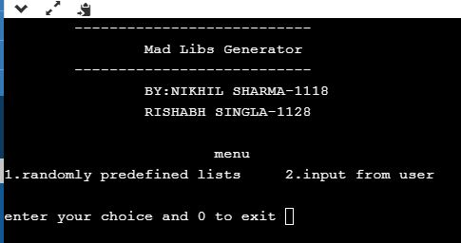

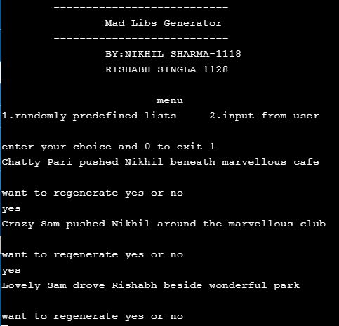

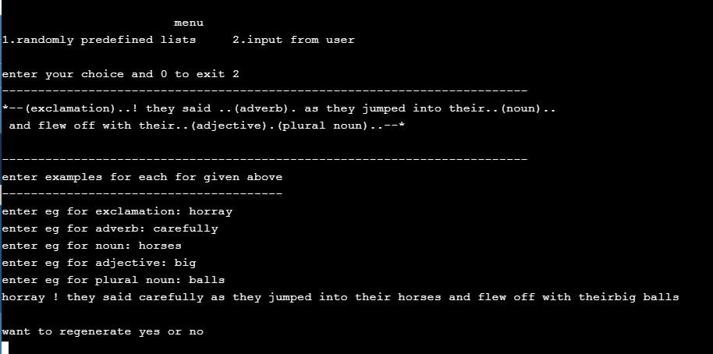

**GOOGLE DRIVE LINK FOR VIDEO:**

**https://drive.google.com/file/d/1ZhewVpBsEqKo3Iyb3X0ZwRu_JtuGppbN/view?usp=drivesdk**